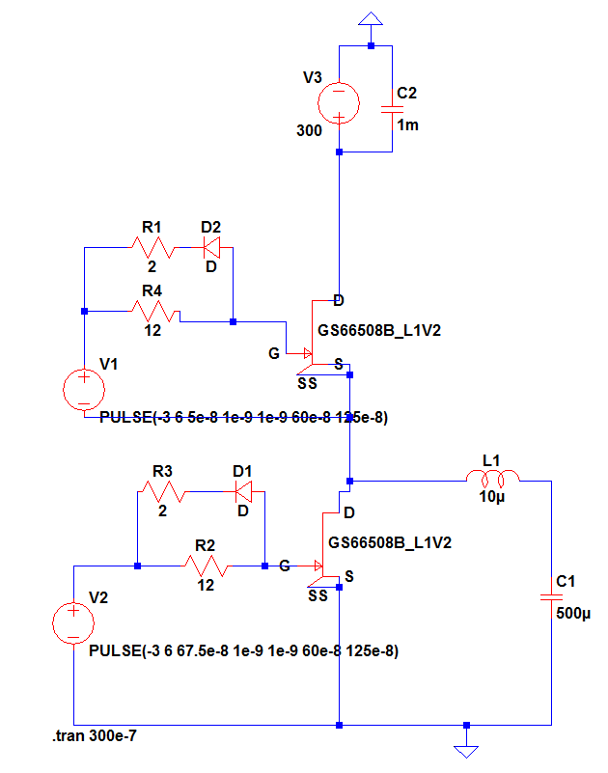

Figure : Circuit Diagram

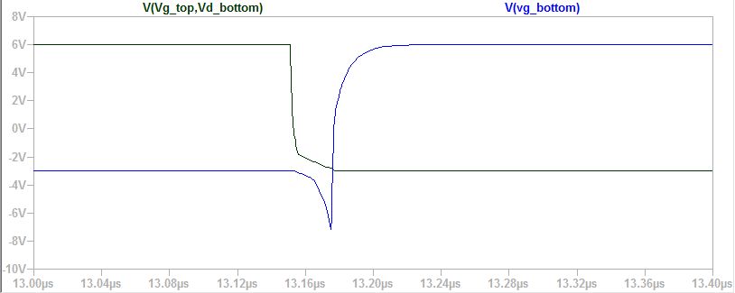

Figure : Top Turn - OFF, Bottom Turn - ON

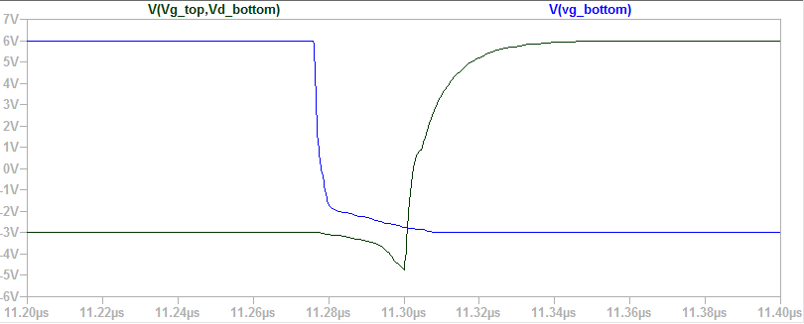

Figure :Top Turn - ON, Bottom Turn - OFF

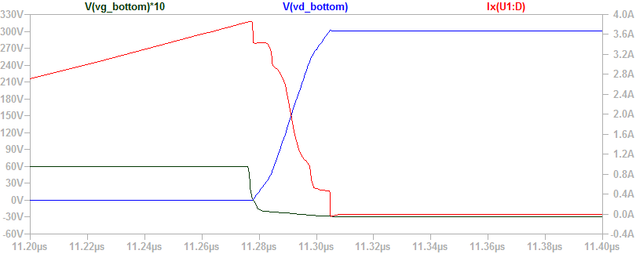

Figure : Bottom Characteristics (Vgs, Vds, Ids) – Turn OFF

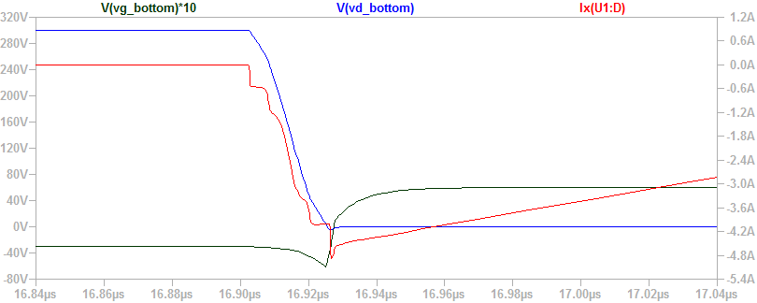

Figure : Bottom Charac. - Turn ON

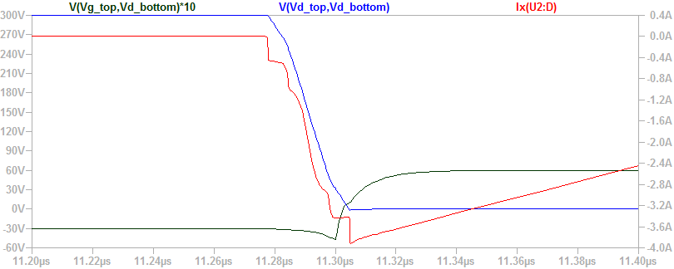

Figure : Top Characteristics, Turn – OFF

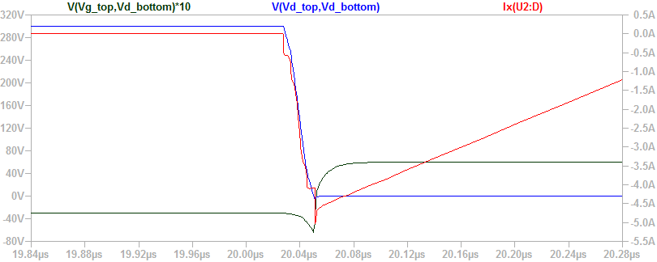

Figure : Top Characteristics - Turn ON